The Historical Books

1. History of the Biblical World

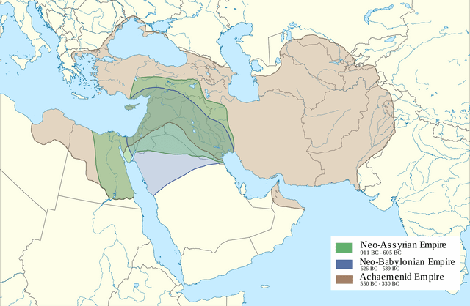

1. The Former Prophets (Deuteronomistic History)
   1. These are the books of Joshua, Judges, Samuel, and Kings
   2. 1-2 Samuel are a single book. The same is true of 1-2 Kings.
   3. Joshua: The story of the conquest of Canaan
   4. Judges: Repeating cycles of 1) Apostasy; 2) Suffering; 3) Repentance; 4) Deliverance through a Judge
   5. Samuel
      1. 1 Samuel 1-15: The rise and decline of King Saul
      2. 1 Samuel 16 - 2 Samuel 10: The rise of David as king
      3. 2 Samuel 11 - 20: David's fall and struggle to retain power
      4. 2 Samuel 21 - 24: Epilogue
   6. Kings: Rise and Fall of Israel and Judah based on the conduct of their kings
   7. Key Themes
      1. Worship at Jerusalem
         1. **Deuteronomy 12:4-6** You shall not worship the LORD your God in [the ways of the Canaanites]. 5 But you shall seek the place that the LORD your God will choose out of all your tribes as his habitation to put his name there. You shall go there, 6 bringing there your burnt offerings and your sacrifices, your tithes and your donations, your votive gifts, your freewill offerings, and the firstlings of your herds and flocks.
      2. A Faithful King
         1. **Deut 17:14-20** When you have come into the land that the LORD your God is giving you, and have taken possession of it and settled in it, and you say, "I will set a king over me, like all the nations that are around me," 15 you may indeed set over you a king whom the LORD your God will choose. One of your own community you may set as king over you; you are not permitted to put a foreigner over you, who is not of your own community. 16 Even so, he must not acquire many horses for himself, or return the people to Egypt in order to acquire more horses, since the LORD has said to you, "You must never return that way again." 17 And he must not acquire many wives for himself, or else his heart will turn away; also silver and gold he must not acquire in great quantity for himself. 18 When he has taken the throne of his kingdom, he shall have a copy of this law written for him in the presence of the levitical priests. 19 It shall remain with him and he shall read in it all the days of his life, so that he may learn to fear the LORD his God, diligently observing all the words of this law and these statutes, 20 neither exalting himself above other members of the community nor turning aside from the commandment, either to the right or to the left, so that he and his descendants may reign long over his kingdom in Israel.
      3. Prophets as Spokespersons for God
2. Chronicles: A Revised History of Judah
   1. What’s New in Chronicles?
      1. Genealogies
      2. David and Solomon are Flawless
      3. Chronicles Ignores the Northern Kingdom
      4. Chronicles Focuses on the Temple and Religion
      5. Royal Reigns Follow a Sequence from Good to Bad
      6. Chronicles Ends on a Note of Hope
         1. **2 Chr 36:22-23** In the first year of King Cyrus of Persia, in fulfillment of the word of the LORD spoken by Jeremiah, the LORD stirred up the spirit of King Cyrus of Persia so that he sent a herald throughout all his kingdom and also declared in a written edict: "Thus says King Cyrus of Persia: The LORD, the God of heaven, has given me all the kingdoms of the earth, and he has charged me to build him a house at Jerusalem, which is in Judah. Whoever is among you of all his people, may the LORD his God be with him! Let him go up."
   2. Comparing Kings and Chronicles
      1. David's Census
         1. **1 Chronicles 21:1-2** Satan stood up against Israel, and incited David to count the people of Israel. So David said to Joab and the commanders of the army, "Go, number Israel, from Beer-sheba to Dan, and bring me a report, so that I may know their number."
         2. **2 Sam 24:1-2** Again the anger of the LORD was kindled against Israel, and he incited David against them, saying, "Go, count the people of Israel and Judah." So the king said to Joab and the commanders of the army, who were with him, "Go through all the tribes of Israel, from Dan to Beer-sheba, and take a census of the people, so that I may know how many there are."
      2. Building the Temple
         1. **1 Kings 6:38 - 7:1** In the eleventh year, in the month of Bul, which is the eighth month, the house was finished in all its parts, and according to all its specifications. He was seven years in building it. Solomon was building his own house thirteen years, and he finished his entire house.
         2. **2 Chr 5:1** Thus all the work that Solomon did for the house of the LORD was finished. Solomon brought in the things that his father David had dedicated, and stored the silver, the gold, and all the vessels in the treasuries of the house of God.
      3. Manasseh's reign
         1. **2 Kings 21:16-18** Manasseh shed very much innocent blood, until he had filled Jerusalem from one end to another, besides the sin that he caused Judah to sin so that they did what was evil in the sight of the LORD. Now the rest of the acts of Manasseh, all that he did, and the sin that he committed, are they not written in the Book of the Annals of the Kings of Judah? Manasseh slept with his ancestors, and was buried in the garden of his house, in the garden of Uzza. His son Amon succeeded him.
         2. **2 Chr 33:10-13** The LORD spoke to Manasseh and to his people, but they gave no heed. Therefore the LORD brought against them the commanders of the army of the king of Assyria, who took Manasseh captive in manacles, bound him with fetters, and brought him to Babylon. While he was in distress he entreated the favor of the LORD his God and humbled himself greatly before the God of his ancestors. He prayed to him, and God received his entreaty, heard his plea, and restored him again to Jerusalem and to his kingdom. Then Manasseh knew that the LORD indeed was God.